

**NUTECH VENTILATOR**

**SOFTWARE REQUIREMENT SPECIFICATION**

Version 3.0

Revision History

|  |  |  |  |  |  |  |
| --- | --- | --- | --- | --- | --- | --- |
| **Title** | **Document Version #** | **Changes in Current Version** | **Date of Release**  **(Current)** | **Approved Signature** | **Previous**  **Version**  **#** | **Date of Release**  **(Previous)** |
| NuVENT Software Requirement Specification document | v1.0 | Creation of document, General functional requirements are included | 25.06.20 |  | - | - |
|  | v2.0 | System interfaces are added, Alarms requirements are added | 01/08/2020 |  | v1.0 | 25.06.20 |
|  | V3.0 | Modified document as per change in design | 23/09/2020 |  | V2.0 | 01/08/2020 |

Table of Contents

1. Introduction 5

1.1. Purpose 5

1.2. Scope 6

1.3. Abbreviated Terms and Definitions 7

1.4. Conformance 10

2. Overall description 12

2.1. Product Perspective 12

2.2 Classification of NuVENT 12

2.3. Stakeholders and User Classes 19

2.4. Operating Environment 21

2.5. Constraints 21

3. Operations 21

3.1. NuVENT States 21

3.2. NuVENT Operation Modes 23

3.3. Invasive and Non-Invasive Ventilation 26

4. Requirements 26

4.1. Functional Requirements 26

4.2. Alarm Requirements 34

4.3. Performance Requirements 40

4.4. Usability Requirements 41

4.5. System software attributes 42

5. External interfaces 43

5.1. User interfaces 43

5.2. Communication Interfaces 51

6. Standards compliance 51

LIST OF TABLES

Table 1:Pneumatic system Components 13

Table 2: Electrical System Components 17

Table 3: NuVENT Software Components 18

Table 4: Stakeholders and Users of NuVENT 19

LIST OF FIGURES

Figure 1: NuVENT Pnuematic System 13

Figure 2: NuVENT Pneumatic System Block Diagram 13

Figure 3:NuVENT Patient Circuit 16

Figure 4 CPU PCB and related Battery sources of Electrical System 16

Figure 5: Apalis iMX6 CPU PCB of NuVENT 17

Figure 6: NuVENT Ventilator Working Prototype 18

Figure 7: NuVENT Stop/Shut down State 22

Figure 8: NuVENT Power Down State 23

Figure 9: NuVENT Graphical User Interface 43

Figure 10: Selected Ventilation Mode Panel 43

Figure 11: Adjustable Ventilation Parameters Control Panel 44

Figure 12: Monitored Ventilation Parameters Control Panel 45

Figure 13: General Settings Panel 45

Figure 14: Ventilator Settings Panel 46

Figure 15:Waveform Area Panel 46

Figure 16:Ventilator Settings Dialog-VC-AC Mode 47

Figure 17:Ventilator Settings Dialog-PC-AC Mode 47

Figure 18:Ventilator Settings Dialog- VCV Mode 47

Figure 19:Ventilator Settings Dialog- PCV Mode 48

Figure 20:Ventilator Settings Dialog- VC-SIMV Mode 48

Figure 21:Ventilator Settings Dialog- PC-SIMV Mode 48

Figure 22:Ventilator Settings Dialog- PC-PSV Mode 49

Figure 23:Ventilator Settings Dialog- BIAP Mode 49

Figure 24: Ventilator Settings Dialog- CPAP Mode 49

Figure 25: Alarm Setting Dialog 50

Figure 26: Start/Standby Dialog 50

Figure 27:Alarm Setting Dialog- Tube/NIV 51

1. Introduction

The devastation brought about by the life threatening acute respiratory syndrome coronavirus 2 (SARS-CoV-2, also known as COVID-19) in the communities up and down across the world has been unprecedented and a profoundly distressing experience. In the severe cases, the virus causes damage to the lungs, causing the body’s oxygen levels to drop and making it harder to breathe. To alleviate this, a ventilator is used to push air, with increased levels of oxygen, into the lungs. Simply put, a ventilator takes over the body’s breathing process when disease has caused the lungs to fail. This gives the patient time to fight off the infection and recover. These ventilators are all targeted at patients with chronic respiratory failure.

Ventilators have become a commodity in extremely high demand, far outstripping the available supply. They typically cost approximately $30,000 each. However, a number of innovative grassroots initiatives, built in weeks by altruistic engineers with distributed design methodologies and open-source licenses, have sprung up to try and solve the shortage.

The NUVENT (Nutech Ventilator System) is designed for both non-ventilation dependent and ventilation-dependent patients including but not limited to COVID-19 patients. Typically, chronically ventilated patients have a variety of restrictive and obstructive pathologies, encompassing Chronic obstructive pulmonary disease (COPD), neuromuscular diseases (ALS, muscular dystrophy, spinal cord damage), and thoracic cage diseases (scoliosis, extreme obesity, etc.). NuVENT application is remotely accessible and system is compatible with single limb and double limb circuits

This document provides the features of NuVENT system, atomizing the details of each feature into requirements mapping dependencies between the requirements, describing the stakeholders and users involved in making effective use of these functionalities.

* 1. Purpose

Ventilators are mechanical breathing machines which are essential for critical patients of COVID-19 — a disease that directly affects the patient’s lungs. In severe cases, the patients develop pneumonia that can fill the lower lungs with fluid and cause difficulty in breathing; the condition can lead to a critical deficiency of oxygen [in a patient’s body]. A ventilator thus provides life-saving oxygenation when the patient is not able to do it on his/her own.

According to Pakistan’s National Command and Operation Centre, country only had 3,844 ventilators and 20 labs capable of conducting COVID-19 tests. Out of these, the authority said 1,697 ventilators were in Punjab, 1,550 in Sindh, 400 in Khyber Pakhtunkhwa, 74 in Baluchistan, 47 in Islamabad Capital Territory and 13 in Gilgit-Baltistan. Recent reported cases have reached 203K. This difference of cases and life-support ventilators is huge. Global shortage of ventilators has led the scientific and engineering community towards rapid development of ventilators prototypes that will be will be evaluated for mass production of ventilators to meet the national requirement.

Each Ventilator system comes with specialized software that processes the physiological information after receiving from the electrical/mechanical ventilator components. In this regard NuVENT system comes with a NuVENT software application to facilitate clinicians to view and recommend necessary medical procedures by adjusting ventilator parameters.

* 1. Scope
* NuVENT system is to be used for mechanical ventilation of patients. This machine can be integrated with hospital oxygen and medical air supply.
* NuVENT system provides nine different modes for mechanical ventilation of patients. It also provides full time dynamic monitoring and control over patient’s ventilation that can be set by user.
* NuVENT system is designed to be used to give Tidal Volume 200ml-1000ml.
* NuVENT system is designed for adult patients only.
* NuVENT application is developed in QT framework using pyqt5 library that makes it versatile and user friendly.
* NuVENT application software is easy to migrate between integrated development environments (IDE).

This document is applicable to:

* Anyone who are performing research and development in medical devices and learn the basics of ventilator application and incorporating latest technologies to broaden its usage.
* Those who use or plan to operate the ventilator device, working of controls, modes, manipulating parameters to obtain textual as well as graphical interpretations.
  1. Abbreviated Terms and Definitions

1.3.1 Abbreviated Terms

|  |  |
| --- | --- |
| **NuVENT** | National University of Technology Ventilator |
| **O2** | Symbol for Oxygen gas |
| **PSV** | Pressure support ventilation |
| **A/C** | Assist Control mode |
| **AC/DC** | Alternating Current / Direct Current Conversion |
| **BiPAP** | Biphasic Positive Airway Pressure |
| **Bpm** | breaths per minute |
| **CPAP** | Continuous positive airway pressure |
| **COVID-19** | coronavirus disease of 2019 |
| **FiO2** | Fraction of inspired oxygen in every breath |
| **GUI** | Graphical User Interface |
| **I Time** | Inspiratory time measure. |
| **I:E** | Inspiratory to Expiratory ratio |
| **ICU** | Intensive Care Unit |
| **Kpa** | Kilo pascal |
| **Lpm** | Liters per minute (a unit of volume flow rate). |
| **MVe** | Minute Volume |
| **NIV** | Noninvasive ventilation |
| **PAW** | Airway pressure |
| **PC** | Pressure Control. |
| **PC-AC** | Pressure Control Assist/Control |
| **PC-SIMV** | Pressure Control Synchronized Intermittent Mandatory Ventilation |
| **PCV** | Pressure Control Ventilation |
| **PEEP** | Positive End Expiratory Pressure. |
| **Pi** | Inspiratory Pressure (Pi) |
| **PIP** | Peak Inspiratory Pressure. |
| **RR** | Respiratory Rate |
| **SIMV** | Synchronized intermittent Mandatory Ventilation Mode |
| **Ti** | Inspiration Time |
| **UPS** | Uninterrupted Power Supply |
| **VC** | Volume Control |
| **VC-AC** | Volume Control Assist/Control |
| **VC-SIMV** | Volume Control Synchronized Intermittent Mandatory Ventilation |
| **VCV** | Volume Control Ventilation |
| **VT** | Tidal Volume. |
| **VTE** | Volume exhaled by the patient at each exhalation phase |
| **VTI** | Volume delivered to the patient at each inspiratory phase. |

1.3.2. Definitions

**Breath rate:** The total number of breaths, both machine and spontaneous, delivered by a ventilator in one minute.

**Continuous airway pressure**: A positive pressure maintained throughout the breathing cycle; usually associated with unassisted spontaneous breathing but actually occurring during most forms of mechanical ventilation.

**PEEP**: Positive end expiratory pressure. A positive pressure related to atmospheric pressure maintained during expiration; usually associated with assisted ventilation

**Pressure support**: pressure support is a mode in which all breaths are patient triggered, pressure limited and patient cycled.

**Patient Wye:** The connector that joins the inspiratory and expiratory limbs of a two-limb patient circuit to the patient airway.

**Tidal Volume:** The column of gas, either inhaled or exhaled, during a breath.

**Volume Control**: Maintenance of consistent inspiratory volume waveform despite changing respiratory system mechanics, using feedback control with volume signal.

**bpm**

An abbreviation for “breaths per minute,” which is the unit of measure for breath rate (see below).

**Breath Rate**

The total number of breaths, both machine and spontaneous, delivered by a ventilator in one

minute.

**cmH2O**

An abbreviation for “centimeters of water,” which is a unit of measure for pressure.

**Double-Limb Patient Circuit**

Patient circuit with a tube between the ventilator gas outlet and the patient for inspiratory gas and

another tube between the patient and the exhalation block for exhalation gas.

**Exhalation Block**

Part of the ventilator that allows the connection of the exhalation limb of the patient circuit. The

exhalation block is for single-patient use only.

**Exhalation Phase**

Phase of the breath cycle during which the patient exhales.

**Exhalation Tidal Volume (VTE)**

Volume exhaled by the patient at each exhalation phase.

**Exhaled Tidal Volume (VTE)**

Exhaled volume measured for all breath types through the exhalation block. Monitored value available

only with double-limb patient circuit. Exhaled volume is computed using a five-breath average.

**FiO2 Sensor**

The sensor that measures the amount of oxygen being delivered to the patient.

**Inspiratory Phase**

Phase of the breath cycle during which the patient inspires.

**Inspiratory Pressure (Pi)**

The operator-set inspiratory pressure during a pressure control (PC) mandatory breath.

**Leak**

When ventilating with a double-limb circuit in leak configuration, it is the average unexpected leak

during each cycle and over the past 24-hour period. When ventilating with a single-limb circuit

there is no average leak.

**LED**

Light emitting diode; used as indicator lights on the ventilator’s front panel.

**lpm**

Liters per minute (a unit of volume flow rate).

**Sigh**

A sigh is an increased volume of gas delivered to the patient at a set rate (for example, every 50

breaths).

**Spirometry**

Spirometry is the most common of the pulmonary function tests. It measures lung function, specifically the amount and/or speed of air that can be inhaled and exhaled.

**Standby**

The operational mode of the ventilator where it is powered (I/O (power) switch set to the I position),

but is not ventilating the patient.

**Unfreeze**

Resumption of the waveform plot tracing on the ventilator’s display.

* 1. Conformance

1.4.1 Intended usage

* NuVENT ventilator system is developed to be used in ICU units by trained paramedics.
* NuVENT System is used for adult patients who require general types of invasive and non-invasive ventilatory support as prescribed by physician. The general types of ventilatory support includes:
* *Positive Pressure Ventilation.*
* *Assist/Control, SIMV, or CPAP modes of ventilation*
* *Breath types including Volume Control, Pressure Control and Pressure Support*
* NuVENT Software provides simulation results (in form of graphs and figures) while operating patient on ventilator that helps the physicians and medical technicians to better analyze the patient health variations.

1.4.2. Full conformance

This Specification document adheres/conforms to the:

1). *Requirement-engineering-related processes of ISO/IEC/IEEE 15288 and ISO/IEC/IEEE 12207*

*that addresses:*

Stakeholder, end-users desired capabilities into a technical view of a solution that meets the operational needs of the user. This process creates a set of measurable system requirements that specify, from the supplier’s perspective, what characteristics, attributes, and functional and non-functional requirements the system is to possess in order to satisfy stakeholder requirements. As far as constraints permit, the requirements should not imply any specific implementation.

[ISO/IEC/IEEE 15288:2015, 6.4.3.1]

[ISO/IEC/IEEE 12207:2017, 6.4.3.1]

As a result of the successful implementation of the Software Requirements Definition process:

1. Software requirements (functional, performance, non-functional, and interface) and design constraints are defined
2. The system[/software] requirements are analysed.
3. Traceability of software requirements to stakeholder requirements is developed.

[ISO/IEC/IEEE 15288:2015, 6.4.3.2]

[ISO/IEC/IEEE 12207:2017, 6.4.3.2]

The system implements the following activities and tasks in accordance with applicable organization policies and procedures with respect to the System Software Requirements Definition process.

1. Define the functional boundary of the system [software system or element] in terms of the behaviour and properties to be provided.

[ISO/IEC/IEEE 15288:2015, 6.4.3.3 a) 1)]

[ISO/IEC/IEEE 12207:2017, 6.4.3.3 a) 1)]

1. Define the Software requirements definition strategy.

[ISO/IEC/IEEE 15288:2015, 6.4.3.3 a) 2)]

[ISO/IEC/IEEE 12207:2017, 6.4.3.3 a) 2)]

1. Identify and plan for the necessary enabling systems or services needed to support Software requirements definition.

[ISO/IEC/IEEE 15288:2015, 6.4.3.3 a) 3)]

[ISO/IEC/IEEE 12207:2017, 6.4.3.3 a) 3)]

1. Obtain or acquire access to the enabling systems or services to be used.

[ISO/IEC/IEEE 15288:2015, 6.4.3.3 a) 4)]

[ISO/IEC/IEEE 12207:2017, 6.4.3.3 a) 4)]

1. Define each function that the system [software system or element] is required to perform.

[ISO/IEC/IEEE 15288:2015, 6.4.3.3 b) 1)]

[ISO/IEC/IEEE 12207:2017, 6.4.3.3 b) 1)]

1. Identify required states or modes of operation of the software system.

[ISO/IEC/IEEE 12207:2017, 6.4.3.3 b) 2)]

1. Define necessary implementation constraints.

[ISO/IEC/IEEE 15288:2015, 6.4.3.3 b) 2)]

[ISO/IEC/IEEE 12207:2017, 6.4.3.3 b) 3)]

2. Overall description

2.1. Product Perspective

The NuVENT Ventilator is designed for the continuous or alternating mechanical ventilatory support of patients weighing at least 44 lb (20 kg) who require mechanical ventilation.

2.2 Classification of NuVENT

The NuVENT Ventilator provides positive pressure ventilation using an electronically controlled micro-turbine to deliver air and supplemental oxygen to the patient. The key mechanical systems that comprise the NuVENT Ventilator are the described *pneumatic system.*

2.2.1. Pneumatic System

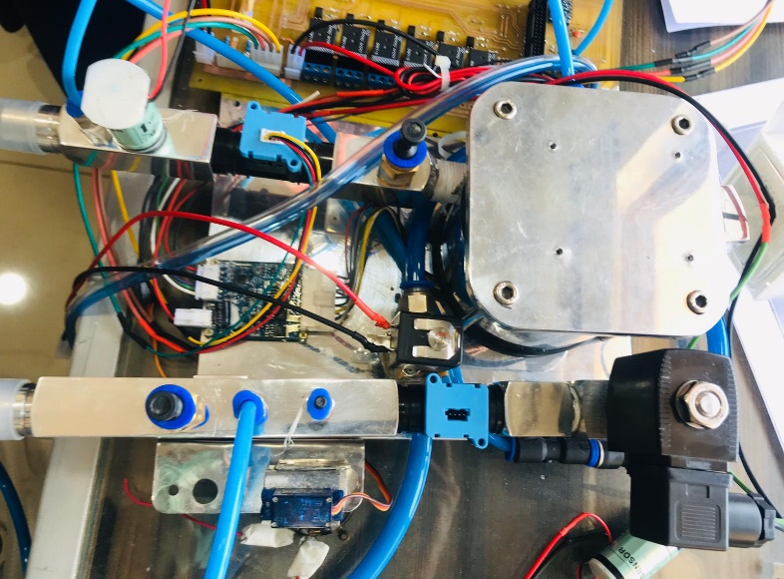A pneumatically powered ventilator uses air and oxygen mixture. This is the power source for most of the intensive care ventilators. Ventilators powered by micro turbine to produce enough volume and pressure that can support ventilation process. This allows uninterrupted operation. Figure 2 shows the block diagram of pneumatic block diagram of the NuVENT.

Figure : NuVENT Pnuematic System

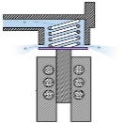

1

10

11

8

12

3

9

13

4

5

7

2



6

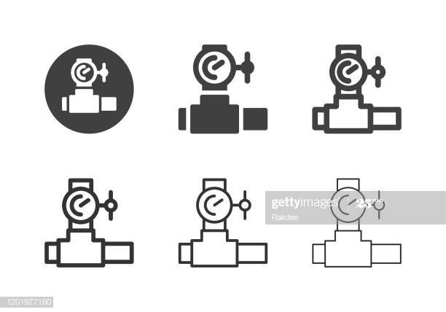

14

Figure 2: NuVENT Pneumatic System Block Diagram

Table 1:Pneumatic system Components

|  |  |  |
| --- | --- | --- |
| **Label #** | **Component Name** | **Description** |
| 1 | **Air inlet filter** | The air inlet filter combines a fine particle filter with a foam backing. The filter traps particles at 3.3 microns with 99.999982% efficiency at 30 lpm flow. |
| 2 | **Turbine/Blower** | The blower of the desired medical ventilator system is run by an electric motor which in turn is controlled by an electronic motor controller. The electronic motor controller provides a pulse width modulated (PWM) signal to the electric motor. By varying the pulse width of this signal, the electronic motor controller can vary the speed at which the motor runs.  The turbine spins at a maximum of 36,000 rpm, and can deliver flows of up to 240 lpm and maximum pressures of 70 cmH2O.  A resistive-type temperature sensor resides in the turbine housing. The CPU monitors the temperature and will shut the turbine down if the temperature rises above 60° C. |
| 3 | **Turbine PCB** | The Turbine Control PCB controls turbine speed and braking and transmits turbine speed and temperature feedback signals to the CPU PCB. The Turbine Control PCB also monitors the current in the turbine motor windings and the position of the motor via a position sensor input signal from the motor. In the event of a turbine malfunction, fault detection signals are generated from the Turbine Control PCB and transmitted to the CPU PCB. A 24 V input from the CPU PCB to the Turbine Control PCB produces a 15 V output to drive the motor controller logic devices. |
| 4 | **Inspiratory flow sensor** | Inspiratory flow sensor (air flow sensor) is located on the CPU PCB measures inspiratory flow. |
| A portion of the inspired flow is measured by the sensor which contains a heated sensing element and internal circuitry used to determine the flow rate. |
| The CPU PCB uses this flow measurement to control the turbine during volume ventilation, determine when an inspiratory flow trigger occurs (based on the inspiratory sensitivity setting), determine the beginning of exhalation (based on the expiratory sensitivity setting), and to calculate ***inspired tidal volume***. |
| 5 | **Exhalation flow sensor** | Exhalation flow sensor (air flow sensor) is located on the CPU PCB |
| 6 | **Inspiratory pressure sensor** | The inspiratory pressure sensor is located on the PCB. It measures pressure of the gas as it exits the ventilator. |
| 7 | **Exhalation pressure sensor** | The exhalation pressure sensor is located on the PCB |
| 8 | **Differential pressure sensor** | The SDP800 sensor, which is a digital differential pressure sensor designed for high-volume applications is being used in our design. The sensors measure the pressure of air and non-aggressive gases with superb accuracy and no offset drift. The sensors cover a pressure range of up to ±500 Pa (±2 inch H2O / ±5 mbar) and deliver outstanding accuracy, also at the bottom end of the measuring range. The SDP800 Series features a digital 2-wire I2C interface, which makes it easy to connect directly to a microprocessor. |
| 9 | **FiO2 Sensor** | The FiO2 sensor is used to monitor percentage of oxygen being delivered to the patient. |
| 10 | **Inspiratory block** | The inspiratory block provides the means for inspiratory flow and pressure  measurements. It includes a one way valve which creates a small pressure drop used to divert a portion of the inspired gas to the inspiratory flow sensor. This gas flows through a one way valve, the flow sensor, and FiO2 sensor, then out through the ventilator’s To Patient port. Pressure ports for inspiratory measurements are also located in the inspiratory block. |
| 11 | **Exhalation Block** | When using a dual limb patient circuit, the exhalation block provides the means to measure exhaled flow. A pressure drop is created as exhaled gas passes through an opening in the exhalation block. Pressure taps, located on either side of the opening, provide the connections to the exhalation flow sensor on the CPU PCB. |
| 12 | **Oxygen Proportional Valve** | The oxygen proportional valve is a normally closed 0-5V DC two-way valve that is used to prevent oxygen from accumulating inside the ventilator. It opens when the ventilator is powered on and ventilating, and closes when the ventilator is in Standby or turned off. |
| 13 | **Exhalation Solenoid Valve** | The exhalation solenoid valve is an electromagnetic, two-way valve mounted on the CPU PCB. It is used to control the pressure on the patient circuit exhalation valve diaphragm throughout the breathing cycle. Pressure supplied from a port at the turbine connects to output port.  The voltage on the exhalation solenoid valve is under closed-loop control on a breath-to breath basis using measurements from the inspiratory flow sensor. During inspiration, turbine gas flows from output port to input port to apply pressure to the diaphragm to completely close the exhalation valve. At the beginning of exhalation, flow from the turbine is vented from input port, relieving pressure on the exhalation valve diaphragm. This allows an initial purge flow and accompanying bias flow to flush the patient’s exhaled gas from the patient circuit for the duration of exhalation. During exhalation without PEEP, the flow path from input port is completely open allowing purge and bias flows. During exhalation with PEEP, flow is directed form output port to HME filter and exhalation valve to remove the accumulated gas from the patient. |
| 14 | **Pressure Oxygen valve** | The minimum oxygen source pressure is approximately 2.5bar. A special coupling is provided with the ventilator to connect the oxygen supply hose to the inlet connector. |

2.2.2 Patient Circuit System

NuVENT Ventilator can be used with a double-limb patient circuit. Patient circuit use an exhalation valve to allow ventilation with a set PEEP level.

* The *double-limb circuit* is special patient circuit having both an inspiratory and an expiratory limb with a proximal pressure line connected to inspiratory limb.
* A *humidifier* and water traps can be used with either circuit as shown in Figure below. The patient must wear a vented NIV interface if a single-limb circuit without an exhalation valve is used.

|  |  |  |
| --- | --- | --- |
| **Label #** | **Component Name** | **Description** |
| **1** | Inspiratory bacteria filter | Bacterial filter is a filter fine enough to prevent the passage of bacteria (0.5–5 μm in diameter), which permits removal of bacteria from solutions. Viruses are considerably smaller, and will pass through a bacterial filter |
| **2** | Dual limb patient circuit | The double-limb circuit allows for exhaled tidal volume measurements by routing exhaled gas through the exhalation  Double-limb circuits are used with breathing modes where spirometry is required |
| **3** | Humidifier | Active humidifiers act by allowing air passage inside a heated water reservoir. These devices are placed in the inspiratory limb of the ventilator circuit, proximal to the ventilator. After the air is loaded with water vapor in the reservoir, it travels along the inspiratory limb to the patient's airway |
| **4** | Exhalation bacteria filter | Designed to prevent bacteria in the patient's exhaled gas from being vented into room medical air. Provides a cost-effective alternative to replacing reusable filters when they become saturated with humidified gas or unused aerosol medications. |
| **5** | Water traps | The water trap is used to collect condensation in the circuit to prevent it from damaging the ventilator or flowing backing to the patient. ... This also helps to minimize the risk of cross contamination to ensure clinician and patient safety. |
| **6** | Exhalation valve at outlet of exhalation block |  |

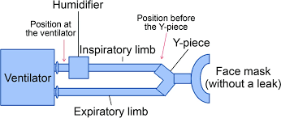

Figure :NuVENT Patient Circuit

2.2.3 Electrical System

This section describes the components of the electrical system and their functions.

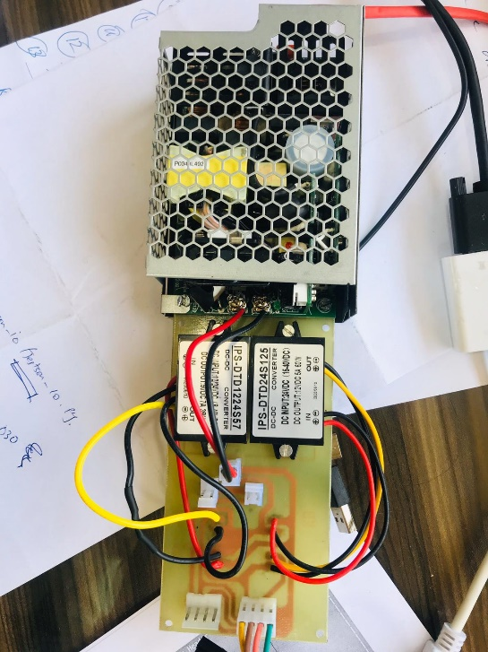

Figure :Battery sources of Electrical System

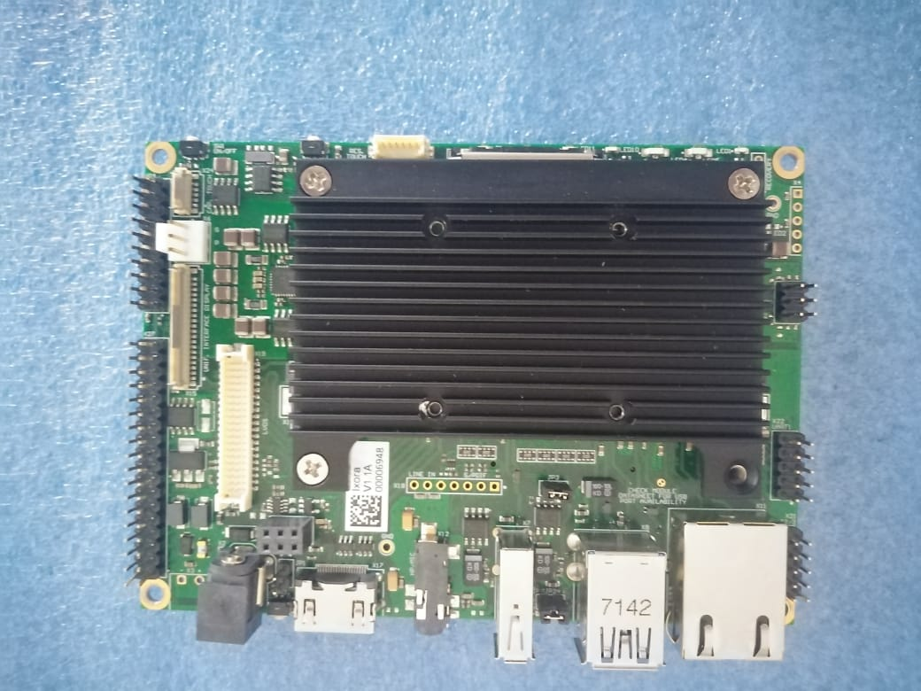

Figure :Apalis iMX6 CPU PCB of NuVENT

Table : Electrical System Components

|  |  |  |
| --- | --- | --- |
| **Sr #** | **Component Name** | **Description** |
| **1** | **Power Management PCB** | The Power Management PCB performs the following functions :   * perform AC / DC voltage conversion * regulates, and distributes DC voltages * manages internal battery charging and discharging * prioritizes the use of AC, external DC and internal battery power sources |
| **2** | **AC to DC Conversion** | The rectifiers used in main power supply convert 220V AC into 24V DC. |
| **3** | **DC Voltage Conversion and Distribution** | The 2v DC from the main power supply to the Power Management PCB which contain buck converters of 5V and 12V:   * 24 V — Used to supply the turbine and fan directly from the Power Management PCB, and distributed to the CPU PCB. The current output is limited to 12.5 A. * 5 V — Used by the Power Management PCB electronics and distributed to the CPU PCB for relay module. The current output is limited to 7 A. |
| **4** | **Internal Battery** | The rechargeable internal battery is a 2x12 V lead dry cell batteries that are connected to uninterrupted power supply unit (UPS). The overall backup time is 1.5 hours. |

2.2.4 Software System

Software system of NuVENT refers to user interface that contains all possible controls that are used to set the ventilation and monitoring parameters and display the monitored parameters and graphics (waveforms and other important control settings).

Table : NuVENT Software Components

|  |  |  |
| --- | --- | --- |
| **Label #** | **Component Name** | **Description** |
| **1** | **LCD Display** | Shows information about the ventilator, including ventilation modes, settings, monitored parameters and calculated patient data and waveforms. The display also allows the user to view and, using the control panel, adjust the ventilator’s operating and alarm configuration settings. |
| **2** | **Control panel** | Provide the basic controls to operate ventilator system that includes   * Setting up ventilator operation * Indicating ventilation on/off status |

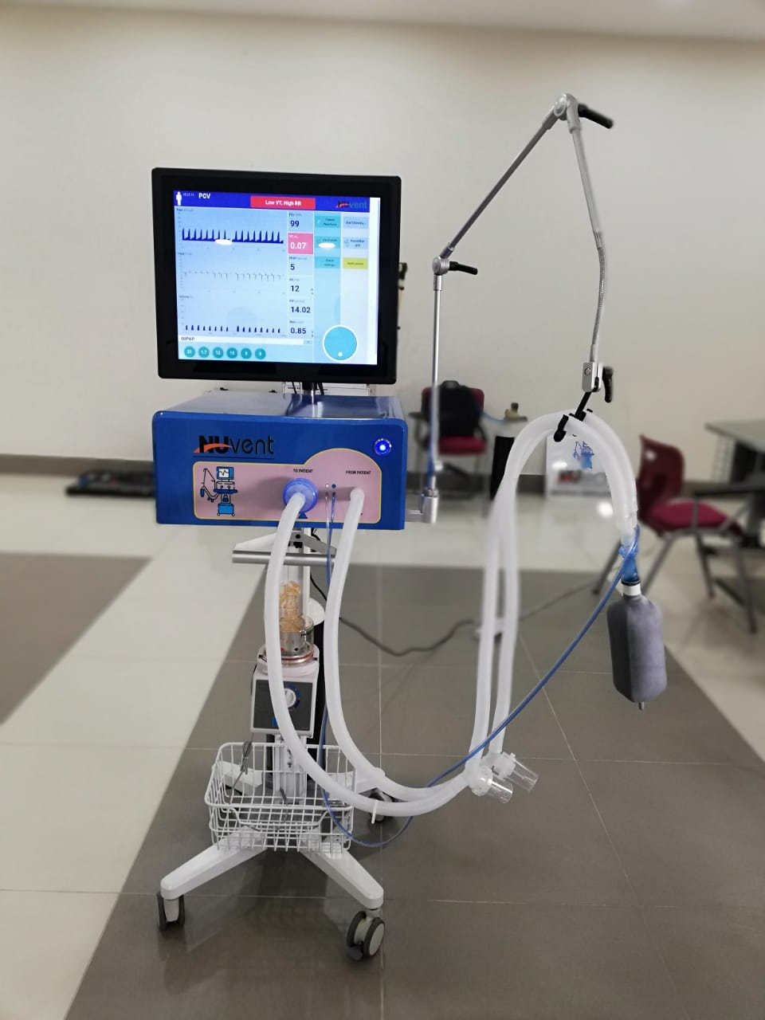

Figure 6: NuVENT Ventilator Working Prototype

2.3. Stakeholders and User Classes

The below table provides the list of stakeholders of NuVENT along with their role & responsibilities in requirement engineering process:

Table 4: Stakeholders and Users of NuVENT

|  |  |
| --- | --- |
| Software development Team | |
| Product Manager | * Develop, design and manage new product development from concept to production, coordinating with sales, marketing and manufacturing functions. * Develop layout, prints and tolerance analysis of components and devices. * Analyse customer specifications and determine new product design criteria. * Evaluate material selection, cost analysis, and vendors as required to implement new designs. * Review the selection and specification of new purchased component parts for product designs. * Create new product concepts that sustain a competitive advantage in the medical device industry. * Determine and establish specifications through engineering calculations and layouts. * Assist Manufacturing/Quality Engineers on analysing designs to determine the availability of machinery and equipment and to determine if customer specifications are suitable to run production. * Assist Manufacturing/Quality Engineers on identifying what processes are required to efficiently build the parts. * Create and manage plans and schedules that identify tasks and resources associated with new product development projects. * Develop and implement Engineering Change Notices when required. * Coordinate and review the testing of new designs, interpret test data, recommend and implement necessary corrective actions. * Oversee the transition from design into production, including any necessary testing and tooling required for implementing new or changed designs. * Assist Manufacturing/Quality Engineers on analysing BOMs, routers and process sheets and verifying their accuracy. * Oversee the prototyping and testing of new designs, including the interpretation of test results. * Maintain close contact and provide engineering technical support to customer service, the shop floor and customers; listen and address questions or concerns as they arise. * Review and evaluate returned product and determine root cause of failures and disposition of materials. * Make cost effective decisions and create processes aligned with feedback and production capability * Understand the technical attributes of a wide range of precision, mechanical products. |
| Hardware Design Engineer | * Development of systems and printed circuit boards for medical products (E.g. life support ventilators). * Work with other Engineers (Electrical, Mechanical, Biomedical) to implement design solutions for defined systems. * Design of mixed system electronics with complex microprocessor, micro-controller, DSP, and analog circuitry for medical device applications. * Provide expertise in the area of high precision analog and digital electronics circuits to include circuit design, prototype development, * Performs system-level, board-level or component-level analysis. |
| Software Test Engineer | * Perform Verification & Validation Activities of NuVENT Software * Ensures successful, on-time completion of department projects; communicates constraints to direct management when successful project completion is at risk * Work in a team environment interacting with product engineers, designers, architecture, applications to achieve common goal of successful product launch. * Effectively communicating progress of test development, implementation, debugging, sustaining support for test programs for production, qualification support and device characterization. * Release testing deliverables (Test case reports, Test Reports, bug Reports |
| Quality Engineer | * Test Planning, Test case design, Test cases writing, Test case review and test results reviews, Defect Logging, Defect Analysis. Regression testing * Able to create Test Cases from the Functional Specifications / Software Requirement Specification document. * Able to test the Functionality as per the Test plan and respective Test Cases. * Release deliverables and project administrative activities |
| Product Owners/partners | The Product Owner represents the client and users of the product.  They are responsible for maximum return on investment for the client and communicating what product features should be at the top of the priority list. |
| Medical Team | |
| Respiratory therapists | Respiratory therapists use protocols, or guidelines, to adjust the controls of ventilator device and software, and they discuss changes and improvements with the team on a daily basis. |
| Physician (Pulmonologists) | Responsible for key decisions regarding ventilation and weaning; use of ventilation protocols and automated closed loop systems; and provision of education on mechanical ventilation. |
| Nurses | Managing the ventilator and its surrounding, verifying the ventilator modes of operation, providing vigilant support to physician, noticing the alarms and  warnings, |
| Patients | Patient is the end-user of ventilator device that is attached with it. Patient inhales the positive pressure provided by the ventilator. |

2.4. Operating Environment

Mechanical ventilators are used in a variety of settings, from the operating room (OR) and intensive care unit (ICU) to the home and transport vehicles.

2.5. Constraints

2.5.1. Design constraints

#### One patient data is displayed and managed in NuVENT Graphical user interface.

* Current model of mechanical ventilator supports only adult patients, however a design control of pediatric patient will be added in new versions.
* Waveform information, measured and set parameters information is calculated, displayed but not stored. (In Future this information will be managed in specialized repository for analysis).
* If a power down occurs and UPS is discharged as well, then on the next power on the ventilator does not start directly in active ventilation state with the previous settings.

2.5.2. Other constraints

* Ventilator software is restricted to be operated only by trained professionals (physicians, paramedics, therapists and system engineers of this field).
* Due to the internal battery’s limited reserve capacity, the ventilator should only be operated on the internal battery when no other power source is available.
* Database/Repository to keep the record of ventilation traces, monitored values is not yet provided
* Only double limb circuit is supported
* NuVENT provides O2 intake port and connector, delivering O2 at minimum of 2.5 bar pressure.
* Ventilator Ports compatible with 18-20 mm I.D. tubing

3. Operations

3.1. NuVENT States

3.1.1. NuVENT Start-Up State

When the ventilator is powered on using AC power source, the ventilator panel runs Power Self-Test (POST) for approximate 15 seconds and ventilator will be in Start Up State. On the User Interface, LCD device will show the GUI after approximately 5 to 10 seconds. The default mode which is shown in GUI in VC-AC mode.

If the ventilator could not start up due to any critical fault then a message will be shown which will ask attendant to restart the ventilator.

In order to ensure proper correct working, it is highly recommended to use “SELF TEST” after start-up from the ventilator settings. 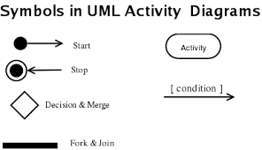

3.1.2. NuVENT Stop/Shut down State

If the ventilation is on and the POWER BUTTON is pressed and released, the software will display a message “ Do you want to Shutdown Ventilator” and if Ok is pressed then after approximately 10 seconds the whole ventilator will be shutdown.

The popup message will stay on the screen until OK or Cancel is not pressed.

POWER BUTTON = Pressed

**Stop /Shut Down**

-Display confirmation message

-Wait for the user to respond



**Active**

[Message accepted?]

No

Yes

Figure 7: NuVENT Stop/Shut down State

3.1.3. NuVENT Power Down State

If a Power Down occurs while the ventilator is in an Active Ventilation State, the ventilator switches from main power supply to internal batteries. When this state occurs, ventilator continues its function without any notification. If UPS is discharged as well, ventilator will continuous beeps before turning off. Then on the next power on, the ventilator shall start in inactive ventilation state with in VC-AC mode.

**Power Down**

-Switches to internal battery (UPS)

-Ventilator continues ventilation till the UPS is discharged

-Ventilator eill give continuous beeps before turning off



**Active**

Power ON

**Turn Off**

Figure 8: NuVENT Power Down State

3.1.4. NuVENT Active State

When Ventilator is in Active State it allows:

* Changing ventilation mode to any other applicable ventilation mode can be done.
* Changing ventilation current settings to any other applicable ventilation mode, these changes will be Effective at the beginning of the next breath cycle, except for inspiratory trigger level changes which shall apply immediately.
* During active ventilation, the ventilator shall allow changing the settings in any other applicable ventilation mode prior to its activation.

3.1.5. NuVENT In-Active/Stand By State

The ventilator shall allow changing the ventilation mode while ventilation support is in-active (Standby). The ventilator shall allow changes to be made to the settings of the current ventilation mode while ventilation support is inactive (Standby).

3.2. NuVENT Operation Modes

A ventilator mode can be defined as a set of operating characteristics that control how the ventilator functions. An operation mode can be described by the way a ventilator is triggered into inspiration and cycled into exhalation, what variables are limited during inspiration, and whether or not the mode allows only mandatory breaths, spontaneous breaths, or both. In this section NuVENT mode of operations along with breath types will be discussed:

3.2.1. Pressure Support Ventilation (PSV)

This mode of *control breath delivery* is provided with spontaneous or timed breath delivery with *Pressure Support spontaneous Ventilation* to the patient. In this mode the patient will have to be able to both initiate the breath and have enough respiratory strength to take an adequate tidal volume. This ventilation mode shall be compatible with double limb patient circuit. Following observations are verified while operating in this mode.

* In this mode you need to set FIO2, RR, Inspiratory Pressure, PEEP, Differential pressure support.
* It maintains a constant level of pressure in the patient’s airway during exhalation. In addition,

the ventilator applies a clinician-set pressure (Pressure Support) to each of the patient’s

breaths.

* The pressure support ventilation mode is indicated for active patients only.

3.2.2. Volume Assist Control (VC-AC)

This mode of *control breath delivery* is provided to patient with **volume controlled** mandatory ventilation. This ventilation mode shall be compatible with double limb patient circuit. Following observations are verified while operating in this mode.

* In this mode you need to set a FIO2, RR, Inspiratory PEEP, inspiratory time, flow and a tidal volume (Vt).
* Two type of breaths are allowed in this mode: volume assist breaths and volume control breaths.
* Whether initiated by the patient or the ventilator, all breaths are delivered at the same preset

volume and inspiratory time.

* If the patient is awake and triggering’s a breath faster than a threshold bpm, then these breaths will be volume-assisted breaths.

3.2.3. Pressure Assist Control (PC-AC)

This mode of *control breath delivery* is provided to patient with **pressure controlled** mandatory ventilation. This ventilation mode shall be compatible with double limb patient. Following observations are verified while operating in this mode.

* In this mode you need to set PEEP, FIO2, RR, Inspiratory Pressure, Inspiration Time.
* Two type of breaths are allowed in this mode: Pressure assist breaths and pressure control breaths.
* Whether initiated by the patient or the ventilator, all breaths are delivered at the same preset

pressure and inspiratory time.

* If the patient is awake and triggering’s a breath faster than a threshold (bpm), then these breaths will be pressure-assisted breaths.

3.2.4. Volume Control Synchronized Intermittent Mandatory Ventilation (VC-SIMV)

SIMV is capable of delivering all three type of breaths. This mode of synchronized intermittent mandatory ventilation breath delivery is provided to patient with *volume controlled mandatory ventilation*. This ventilation mode shall be compatible with double patient circuit. Following observations are verified while operating in this mode.

* If patient trigger the ventilator at or near every 5th second. The ventilator will synchronize with the patient effort and give an assisted breath if the patient initiates their breath at or within every 5th second.
* If patient triggers during preset respiratory rate then ventilator will synchronize with the new triggered breath rate.
* In this mode you need to set FIO2, VT, Inspiration Time, RR, Flow Rate, PEEP, Differential pressure support.

3.2.5. Pressure Control Synchronized Intermittent Mandatory Ventilation (PC-SIMV)

This mode of synchronized intermittent mandatory ventilation breath delivery is provided to patient with *pressure controlled mandatory* ventilation. This ventilation mode shall be compatible with double circuit. Following observations are verified while operating in this mode.

* In this mode you need to set FIO2, Inspiration Time, RR , PEEP, Inspiratory Pressure, Differential pressure support.

3.2.6. Continuous Positive Airway Pressure (CPAP)

The ventilator shall provide Continuous Positive Airway Pressure (CPAP). This ventilation mode shall be compatible with double limb patient circuits with calibrated leakage.

* In this mode you need to set FIO2, PEEP and Differential Pressure Support.

3.2.7. Biphasic Positive airway pressure (BiPAP)

In this mode NuVENT provides the prescribed pressure for inhalation (IPAP), and a lower pressure for exhalation (EPAP).

* In this mode you need to set FIO2, Inspiration time, RR, Inspiratory Pressure, PEEP and Differential Pressure Support.

3.2.8. Pressure Controlled Ventilation (PCV)

In this mode NuVENT provides *control breath delivery* to the patients with pressure controlled mandatory ventilation. This ventilation mode is compatible with double limb patient circuit.

* In this mode you need to set FIO2, Inspiration time, RR, Inspiratory Pressure, PEEP .
* This mode is used on patients who have no spontaneous respiration. However, a spontaneously breathing patient can breathe deeply and freely during expiration.

3.2.9. Volume Controlled Ventilation (VCV)

In this mode NuVENT provides *control breath delivery* to the patients with volume controlled mandatory ventilation. This ventilation mode is compatible with double patient circuit.

* In this mode you need to set FIO2, Vt, Inspiration time, RR, Flow, PEEP.
* In VCV, the ventilator delivers the preset tidal volume (Vt) with a constant flow during the preset inspiratory time (Ti) at the preset respiratory rate.

3.3. Invasive and Non-Invasive Ventilation

The ventilator can be used invasively or non-invasively.

1. Requirements

4.1. Functional Requirements

|  |  |
| --- | --- |
| **NUVENT-** **START-001**  Ventilator Start Up Screen | |
| **Version** | v1.0 |
| **Priority** | HP (HP=High Priority, MP= Medium Priority, LP = Low Priority) |
| **Description** | Upon startup, the ventilator shall display NuVent Ventilator Logo and NuVENT Text. Total start up time is 5-10 seconds. |
| **Criticality** | Critical (critical or non-critical) |
| **Risk** | Power failure and Ventilator malfunction. |
| **Source** | PEC-ATP-EM-PMVS :001:2020 |

|  |  |
| --- | --- |
| **NUVENT-** **BATTERY-001**  Battery Charging | |
| **Version** | v1.0 |
| **Priority** | HP (HP=High Priority, MP= Medium Priority, LP = Low Priority) |
| **Description** | NuVENT charges its battery using built in charger and shifts to back up mode when power down occurs. |
| **Criticality** | Critical (critical or non-critical) |
| **Risk** | Power failure and Ventilator malfunction. |
| **Source** | PEC-ATP-EM-PMVS :001:2020 |

|  |  |
| --- | --- |
| **NUVENT-** **VMODE-001**  Pressure controlled Ventilation (PCV) | |
| **Version** | v1.0 |
| **Priority** | HP (HP=High Priority, MP= Medium Priority, LP = Low Priority) |
| **Description** | In this mode NuVENT provides control breath delivery with pressure controlled mandatory ventilation.  This ventilation mode is compatible with double patient circuits. |
| **Criticality** | Critical (critical or non-critical) |
| **Risks** | Increased tidal volume, Low peak pressure, Low respiratory rate, High respiratory rate, High peak pressure, Low flow rate, High flow rate, Low PEEP, High PEEP, Switching delay from VC to PC and vice versa, PIP and Vt of breathes show same curves, Ventilator malfunction, and Circuit obstruction. |
| **Source** | PEC-ATP-EM-PMVS :001:2020 |

|  |  |
| --- | --- |
| **NUVENT-** **VMODE-002**  Volume controlled Ventilation (VCV) | |
| **Version** | v1.0 |
| **Priority** | HP (HP=High Priority, MP= Medium Priority, LP = Low Priority) |
| **Description** | In this mode NuVENT provides control breath delivery with volume controlled mandatory ventilation.  This ventilation mode is compatible with double and single limb patient circuits with an exhalation valve. |
| **Criticality** | Critical (critical or non-critical) |
| **Risks** | Increased tidal volume, Low peak pressure, High peak pressure, Low PEEP, High PEEP, Low flow rate, High flow rate, Low respiratory rate, High respiratory rate, Rise in Plateau pressure, Switching delay from VC to PC and vice versa, PIP and Vt of breathes show same curves, Ventilator malfunction, and Circuit obstruction. |
| **Source** | PEC-ATP-EM-PMVS :001:2020 |

|  |  |
| --- | --- |
| **NUVENT-** **VMODE-003**  Pressure Control Synchronized Intermittent Mandatory Ventilation Mode (PC-SIMV) | |
| **Version** | v1.0 |
| **Priority** | HP (HP=High Priority, MP= Medium Priority, LP = Low Priority) |
| **Description** | In this mode NuVENT provides synchronized intermittent mandatory ventilation breath delivery with pressure controlled mandatory ventilation. This ventilation mode is compatible with double and single limb patient circuits with an exhalation valve. |
| **Criticality** | Critical (critical or non-critical) |
| **Risks** | Increased tidal volume,, Low peak pressure, High peak pressure, Low flow rate, High flow rate, Low respiratory rate, High respiratory rate, Low PEEP, High PEEP, Switching delay from VC to PC and vice versa, PIP and Vt of breathes show same curves, Ventilator malfunction, and Circuit obstruction. |
| **Source** | PEC-ATP-EM-PMVS :001:2020 |

|  |  |
| --- | --- |
| **NUVENT-** **VMODE-004**  Volume Control Synchronized Intermittent Mandatory Ventilation Mode (VC-SIMV) | |
| **Version** | v1.0 |
| **Priority** | HP (HP=High Priority, MP= Medium Priority, LP = Low Priority) |
| **Description** | In this mode NuVENT provides synchronized intermittent mandatory ventilation breath delivery with volume controlled mandatory ventilation. This ventilation mode is compatible with double and single limb patient circuits with an exhalation valve. |
| **Criticality** | Critical (critical or non-critical) |
| **Risks** | Increased tidal volume, Low peak pressure, High peak pressure, Low flow rate, High flow rate, Low respiratory rate, High respiratory rate, Low PEEP, High PEEP, Rise in Plateau pressure, Switching delay from VC to PC and vice versa, PIP and Vt of breathes show same curves, Ventilator malfunction, and Circuit obstruction. |
| **Source** | PEC-ATP-EM-PMVS :001:2020 |

|  |  |
| --- | --- |
| **NUVENT-** **VMODE-005**  Spontaneous with Pressure (PSV) | |
| **Version** | v1.0 |
| **Priority** | HP (HP=High Priority, MP= Medium Priority, LP = Low Priority) |
| **Description** | In this mode NuVENT provides spontaneous or timed breath delivery with Pressure Support spontaneous Ventilation. This ventilation mode is compatible with double and single limb patient circuits with an exhalation valve. |
| **Criticality** | Critical (critical or non-critical) |
| **Risks** | Increased tidal volume, Low peak pressure, High peak pressure, Low flow rate, High flow rate, Low PEEP, High PEEP, Low respiratory rate, High respiratory rate, Switching delay from VC to PC and vice versa, PIP and Vt of breathes show same curves, Ventilator malfunction, and Circuit obstruction. |
| **Source** | PEC-ATP-EM-PMVS :001:2020 |

|  |  |
| --- | --- |
| **NUVENT-** **VMODE-006**  Pressure Control Assist/Control (PC-AC) | |
| **Version** | v1.0 |
| **Priority** | HP (HP=High Priority, MP= Medium Priority, LP = Low Priority) |
| **Description** | In this mode NuVENT provides assist/control or control breath delivery with pressure controlled mandatory ventilation. This ventilation mode is compatible with double and single limb patient circuits with an exhalation valve and single limb patient circuits. |
| **Criticality** | Critical (critical or non-critical) |
| **Risks** | Increased tidal volume, Low peak pressure, High peak pressure, Low flow rate, High flow rate, Low PEEP, High PEEP, Low respiratory rate, High respiratory rate, Rise in Plateau pressure, Switching delay from VC to PC and vice versa, PIP and Vt of breathes show same curves, Ventilator malfunction, and Circuit obstruction. |
| **Source** | PEC-ATP-EM-PMVS :001:2020 |

|  |  |
| --- | --- |
| **NUVENT-** **VMODE-007**  Volume Control Assist/Control (VC-AC) | |
| **Version** | v1.0 |
| **Priority** | HP (HP=High Priority, MP= Medium Priority, LP = Low Priority) |
| **Description** | In this mode NuVENT provides assist/control or control breath delivery with volume controlled mandatory ventilation. This ventilation mode is compatible with double and single limb patient circuits with an exhalation valve. |
| **Criticality** | Critical (critical or non-critical) |
| **Risks** | Increased tidal volume, Low peak pressure, High peak pressure, Low flow rate, Low PEEP, High PEEP, High flow rate, Low respiratory rate, High respiratory rate, Rise in Plateau pressure, Switching delay from VC to PC and vice versa, PIP and Vt of breathes show same curves, Ventilator malfunction, and Circuit obstruction. |
| **Source** | PEC-ATP-EM-PMVS :001:2020 |

|  |  |
| --- | --- |
| **NUVENT- PARAM-001**  Tidal Volume Control (Vt) | |
| **Version** | v1.0 |
| **Priority** | HP (HP=High Priority, MP= Medium Priority, LP = Low Priority) |
| **Description** | Enables to set tidal volumes level of controlled volume cycles  Used in VCV, VC-AC, VC-SIMV. Vt ranges from 200-1000 ml |
| **Criticality** | Critical (critical or non-critical) |
| **Risks** | Increased tidal volume, Low peak pressure, High peak pressure, Low flow rate, Low PEEP, High PEEP, High flow rate, Rise in Plateau pressure, PIP and Vt of breathes show same curves, Ventilator malfunction, and Circuit obstruction. |
| **Source** | PEC-ATP-EM-PMVS :001:2020 |

|  |  |
| --- | --- |
| **NUVENT- PARAM-002**  Positive End Expiratory Pressure (PEEP) | |
| **Version** | v1.0 |
| **Priority** | HP (HP=High Priority, MP= Medium Priority, LP = Low Priority) |
| **Description** | Enables to set Positive End Expiratory Pressure during exhalation phase  Used in all modes of ventilator  PEEP ranges from 0-20 cmH2O |
| **Criticality** | Critical (critical or non-critical) |
| **Risks** | Low peak pressure, High peak pressure, Low PEEP, High PEEP, Rise in Plateau pressure, PIP and Vt of breathes show same curves, Ventilator malfunction, and Circuit obstruction. |
| **Source** | PEC-ATP-EM-PMVS :001:2020 |

|  |  |
| --- | --- |
| **NUVENT- PARAM-003**  FiO2 | |
| **Version** | v1.0 |
| **Priority** | HP (HP=High Priority, MP= Medium Priority, LP = Low Priority) |
| **Description** | The concentration of oxygen in the air that we breathe is called the FiO2 (Fraction of inspired oxygen).  Enables to set specific percentage of O2 during inspiration phase  Used in all modes  FiO2 adjustment ranges from 20% – 100% |
| **Criticality** | Critical (critical or non-critical) |
| **Risks** | Low FiO2, Ventilator malfunction, and Circuit obstruction. |
| **Source** | PEC-ATP-EM-PMVS :001:2020 |

|  |  |
| --- | --- |
| **NUVENT- PARAM-004**  Flow Rate | |
| **Version** | v1.0 |
| **Priority** | HP (HP=High Priority, MP= Medium Priority, LP = Low Priority) |
| **Description** | Enables to set different flow profile for ventilator to deliver the target inspiratory volume.  Used in VC-AC, VCV, VC-SIMV  Flow ranges from 0-120 lpm |
| **Criticality** | Critical (critical or non-critical) |
| **Risks** | Increased tidal volume, Low peak pressure, High peak pressure, Low flow rate, Low PEEP, High PEEP, High flow rate, Low respiratory rate, High respiratory rate, Rise in Plateau pressure, PIP and Vt of breathes show same curves, Ventilator malfunction, and Circuit obstruction. |
| **Source** | PEC-ATP-EM-PMVS :001:2020 |

|  |  |
| --- | --- |
| **NUVENT- PARAM-005**  Respiratory Rate Control (RR) | |
| **Version** | v1.0 |
| **Priority** | HP (HP=High Priority, MP= Medium Priority, LP = Low Priority) |
| **Description** | Enables to set breathing rate level of controlled pressure or volume cycles  Used in PCV, VCV, PC-AC, VC-AC, PC-SIMV, VC-SIMV modes  RR ranges from 8-35 bpm |
| **Criticality** | Critical (critical or non-critical) |
| **Risks** | Increased tidal volume, Low peak pressure, High peak pressure, Low flow rate, Low PEEP, High PEEP, High flow rate, Low respiratory rate, High respiratory rate, Rise in Plateau pressure, PIP and Vt of breathes show same curves, Ventilator malfunction, and Circuit obstruction. |
| **Source** | PEC-ATP-EM-PMVS :001:2020 |

|  |  |
| --- | --- |
| **NUVENT- PARAM-006**  Inspiration Time (Ti) | |
| **Version** | v1.0 |
| **Priority** | HP (HP=High Priority, MP= Medium Priority, LP = Low Priority) |
| **Description** | The rate at which the ventilator achieves a target pressure (in pressure control and pressure support modes) or flow rate (in volume control modes)  Used in VC-AC, PC-AC, VC-SIMV, PC-SIMV  Ti adjustment ranges from 0.4 – 3.75 secs with including I/E ratios 1:1,1:2, 1:3 |
| **Criticality** | Critical (critical or non-critical) |
| **Risks** | Low peak pressure, Low flow rate, Low PEEP, High PEEP, High flow rate, Low respiratory rate, High respiratory rate, Rise in Plateau pressure, PIP and Vt of breathes show same curves, Ventilator malfunction, and Circuit obstruction. |
| **Source** | PEC-ATP-EM-PMVS :001:2020 |

|  |  |
| --- | --- |
| **NUVENT- PARAM-007**  Plateau Pressure | |
| **Version** | v1.0 |
| **Priority** | HP (HP=High Priority, MP= Medium Priority, LP = Low Priority) |
| **Description** | Plateau pressure is the pressure that is applied by the mechanical ventilator to the small airways and alveoli. The plateau pressure is measured at end-inspiration with an inspiratory hold maneuver on the mechanical ventilator that is 0.5 to 1 second |
| **Criticality** | Critical (critical or non-critical) |
| **Risks** | Ventilator malfunction, and Circuit obstruction. |
| **Source** | PEC-ATP-EM-PMVS :001:2020 |

|  |  |
| --- | --- |
| **NUVENT- PARAM-008**  PAW Pressure | |
| **Version** | v1.0 |
| **Priority** | HP (HP=High Priority, MP= Medium Priority, LP = Low Priority) |
| **Description** | Airway pressure is measured during mechanical ventilation.  Airway pressure is typically displayed on the ventilator screen as a function of time. The shape of the airway pressure waveform is determined by flow and tidal volume from the ventilator, lung mechanics, and any active breathing efforts of the patient. |
| **Criticality** | Critical (critical or non-critical) |
| **Risks** | Increased tidal volume, Low peak pressure, High peak pressure, Low flow rate, Low PEEP, High PEEP, High flow rate, Rise in Plateau pressure, PIP and Vt of breathes show same curves, Ventilator malfunction, and Circuit obstruction. |
| **Source** | PEC-ATP-EM-PMVS :001:2020 |

|  |  |
| --- | --- |
| **NUVENT- PARAM-009**  I:E Ratio | |
| **Version** | v1.0 |
| **Priority** | HP (HP=High Priority, MP= Medium Priority, LP = Low Priority) |
| **Description** | Inspiratory time versus exhalation time ratio  Range: 1:1 to 1:3  In normal spontaneous breathing, the expiratory time is about twice as long as the inspiratory time. |
| **Criticality** | Critical (critical or non-critical) |
| **Risks** | Increased tidal volume, Low flow rate, High flow rate, Low respiratory rate, High respiratory rate, PIP and Vt of breathes show same curves, Ventilator malfunction, and Circuit obstruction. |
| **Source** | PEC-ATP-EM-PMVS :001:2020 |

|  |  |
| --- | --- |
| **NUVENT- PARAM-012**  Delta Psupp | |
| **Version** | v1.0 |
| **Priority** | HP (HP=High Priority, MP= Medium Priority, LP = Low Priority) |
| **Description** | Enables to set inspiratory pressure level in assisted pressure cycles  PSV, PC-SIMV  Psupp ranges from 0-40 cmH2O |
| **Criticality** | Critical (critical or non-critical) |
| **Risks** | Increased tidal volume, High peak pressure, High PEEP, High flow rate, Rise in Plateau pressure, PIP and Vt of breathes show same curves, Ventilator malfunction, and Circuit obstruction. |
| **Source** | PEC-ATP-EM-PMVS :001:2020 |

|  |  |
| --- | --- |
| **NUVENT- PARAM-013**  Patient Category | |
| **Version** | v1.0 |
| **Priority** | MP (HP=High Priority, MP= Medium Priority, LP = Low Priority) |
| **Description** | Normally Patient Category has more than one options but in existing system it is set to adult patients only |
| **Criticality** | Critical (critical or non-critical) |
| **Risks** | - |
| **Source** | Process (person, organization, document, or process) |

4.2. Alarm Requirements

|  |  |
| --- | --- |
| **NUVENT- G-ALARM-001**  Adjustable Alarms Settings | |
| **Version** | v1.0 |
| **Description** | Alarm setting screen must display name/abbreviation of monitored Alarm and each type of alarm must carry a unique icon/symbol for representation |
| **Criticality** | Non-critical (critical or non-critical) |
| **Risk** | Ventilator malfunction |
| **Source** | Process (person, organization, document, or process) |
| **Type** | Output |
| **NUVENT- G-ALARM-002**  Adjustable Alarms Settings | |
| **Version** | v1.0 |
| **Description** | Alarm setting screen must display upper limit of monitored Alarm |
| **Criticality** | Non-critical (critical or non-critical) |
| **Risk** | Ventilator malfunction |
| **Source** | Process (person, organization, document, or process) |
| **Type** | Output |
| **NUVENT- G-ALARM-003**  Adjustable Alarms Settings | |
| **Version** | v1.0 |
| **Description** | Alarm setting screen must display lower limit of monitored Alarm |
| **Criticality** | Non-critical (critical or non-critical) |
| **Risk** | Ventilator malfunction |
| **Source** | Process (person, organization, document, or process) |
| **Type** | Output |
| **NUVENT- G-ALARM-004**  Adjustable Alarms Settings | |
| **Version** | v1.0 |
| **Description** | Alarm setting screen must display current value of monitored Alarm |
| **Criticality** | Non-critical (critical or non-critical) |
| **Risk** | Ventilator malfunction |
| **Source** | Process (person, organization, document, or process) |
| **Type** | Output |

|  |  |
| --- | --- |
| **NUVENT- G-ALARM-005**  Adjustable Alarms Settings | |
| **Version** | v1.0 |
| **Description** | Alarm setting screen must display units of measurement of monitored Alarm |
| **Criticality** | Non-critical (critical or non-critical) |
| **Risk** | Ventilator malfunction |
| **Source** | Process (person, organization, document, or process) |
| **Type** | Output |

|  |  |
| --- | --- |
| **NUVENT- G-ALARM-006**  Adjustable Alarms Settings | |
| **Version** | v1.0 |
| **Description** | For Every adjustable alarm, resolution must be provided to increment or decrement the selected alarm setting |
| **Criticality** | Non-critical (critical or non-critical) |
| **Risk** | Ventilator malfunction |
| **Source** | Process (person, organization, document, or process) |
| **Type** | Output |
| **NUVENT- G-ALARM-007**  Adjustable Alarms Settings | |
| **Version** | v1.0 |
| **Description** | When a new patient is placed on the ventilator alarm limits are automatically set to their default values. |
| **Criticality** | Non-critical (critical or non-critical) |
| **Risk** | Ventilator malfunction |
| **Source** | Process (person, organization, document, or process) |
| **Type** | Output |

|  |  |
| --- | --- |
| **NUVENT- G-ALARM-008**  Alarms Volume | |
| **Version** | v1.0 |
| **Description** | When an alarm is activated a speaker should start and message is displayed . When a user click on active alarm button alarm sounds off and mute audio speaker icon appear on it, but alarm still remains active |
| **Criticality** | Non-critical (critical or non-critical) |
| **Risk** | Ventilator malfunction |
| **Source** | Process (person, organization, document, or process) |
| **Type** | Output |
| **NUVENT- G-ALARM-009**  Alarms Volume | |
| **Version** | v1.0 |
| **Description** | Alarm active and Pause icons must be defined. |
| **Criticality** | Non-critical (critical or non-critical) |
| **Risk** | Ventilator malfunction |
| **Source** | Process (person, organization, document, or process) |
| **Type** | Output |
| **NUVENT- G-ALARM-010**  Alarms Messages | |
| **Version** | v1.0 |
| **Description** | When multiple alarms are activated simultaneously, upto 3 alarm messages must be displayed simultaneously and if number of activated alarms is more than 3, it must display “multiple alarm, Please shutdown Vent” message. |
| **Criticality** | Non-critical (critical or non-critical) |
| **Risk** | Ventilator malfunction |
| **Source** | Process (person, organization, document, or process) |
| **Type** | Output |
| **NUVENT- G-ALARM-011**  Alarms Reset Button | |
| **Version** | v1.0 |
| **Description** | Alarm reset button must be provided on Alarm settings screen. When reset button is clicked all possible alarms should be silenced and default values should be assigned. |
| **Criticality** | Non-critical (critical or non-critical) |
| **Risk** | Ventilator malfunction |
| **Source** | Process (person, organization, document, or process) |
| **Type** | Output |

|  |  |
| --- | --- |
| **NUVENT- G-ALARM-012**  RR Alarm | |
| **Version** | v1.0 |
| **Description** | High Priority Patient Disconnection Alarm must be triggered when RR during inspiratory phase is greater than upper limit set in alarm settings, visual and audio changes on GUI will be observed as per standard |
| **Criticality** | Critical (critical or non-critical) |
| **Risk** | Low respiratory rate, High respiratory rate, Ventilator malfunction, |
| **Source** | PEC-ATP-EM-PMVS :001:2020 |
| **Type** | Output |
| **NUVENT- G-ALARM-013**  Leakage Alarm | |
| **Version** | v1.0 |
| **Description** | Alarm must be triggered, when patient circuit get leaked and results in patient disconnection from ventilator, causing the set value PIP to reaches threshold of Maximum PIP. Audio and visual indication should be displayed on GUI |
| **Criticality** | Critical (critical or non-critical) |
| **Risk** | Low peak pressure, Low flow rate, Ventilator malfunction |
| **Source** | PEC-ATP-EM-PMVS :001:2020 |
| **Type** | Output |
| **NUVENT- FIO2-ALARM-001**  FIO2Alarm | |
| **Version** | v1.0 |
| **Description** | Alarm must be triggered, when the oxygen monitored value is below the 22% |
| **Criticality** | Critical (critical or non-critical) |
| **Risk** | Ventilator malfunction |
| **Source** | PEC-ATP-EM-PMVS :001:2020 |
| **Type** | Output |

|  |  |
| --- | --- |
| **NUVENT- VT-ALARM-001**  Tidal Volume Alarm | |
| **Version** | v1.0 |
| **Description** | Alarm must be triggered when value of tidal volume is above the threshold maximum value of tidal volume level |
| **Criticality** | Critical (critical or non-critical) |
| **Risk** | High tidal volume, High peak pressure, High PEEP, Ventilator malfunction, and Circuit obstruction. |
| **Source** | PEC-ATP-EM-PMVS :001:2020 |
| **Type** | Output |

|  |  |
| --- | --- |
| **NUVENT- VT-ALARM-002**  Tidal Volume Alarm | |
| **Version** | v1.0 |
| **Description** | Alarm must be triggered when value of tidal volume is below the threshold minimum value of tidal volume level |
| **Criticality** | Critical (critical or non-critical) |
| **Risk** | Low peak pressure, Low PEEP, Ventilator malfunction, and Circuit obstruction. |
| **Source** | PEC-ATP-EM-PMVS :001:2020 |
| **Type** | Output |
| **NUVENT- MVe-ALARM-001**  Minute Volume Alarm | |
| **Version** | v1.0 |
| **Description** | Alarm must be triggered when value of minute volume is above the threshold maximum value of minute volume level. |
| **Criticality** | Critical (critical or non-critical) |
| **Risk** | High tidal volume, High peak pressure, High PEEP, Ventilator malfunction, and Circuit obstruction. |
| **Source** | PEC-ATP-EM-PMVS :001:2020 |
| **Type** | Output |
| **NUVENT- MVe-ALARM-002**  Minute Volume Alarm | |
| **Version** | v1.0 |
| **Description** | Alarm must be triggered when value of minute volume is below the threshold minimum value of minute volume set in the alarm settings. |
| **Criticality** | Critical (critical or non-critical) |
| **Risk** | Low peak pressure, Low PEEP, Ventilator malfunction, and Circuit obstruction. |
| **Source** | PEC-ATP-EM-PMVS :001:2020 |
| **Type** | Output |

4.3. Performance Requirements

4.3.1. Response time

|  |  |
| --- | --- |
| *NuVENT-PER-1* | Pressure (PAW) , Flow and Volume graphs must be displayed simultaneously |
| *NuVENT- PER -2* | After every 200 milliseconds the waveform curves of flow, pressure and volume must be updated from left towards right |
| *NuVENT- PER -3* | The ventilator shall display the monitored breath rate in the range of 0 to 99 breath/min and with a display resolution of 1 breath/min. |
| *NuVENT- PER -4* | NuVENT must measure Inspiration flow in real time. |

4.3.2. Scalability

|  |  |
| --- | --- |
| *NuVENT- PER -1* | Each waveform should capture 4 to 5 number of pressure, flow and volume cycles |
| *NuVENT- PER -2* | The number of samples delivered to display waveform of pressure ,flow and volume should be at least 5 samples per second. |
| *NuVENT- PER -3* | A single ventilator software is designed to support single patient. |
| *NuVENT- PER -4* | Graphics display includes 20-second pressure waveform. |

4.3.3. Execution Time

|  |  |
| --- | --- |
| *NuVENT- PER -1* | NuVENT Software boot up time must not exceed 15 seconds |
| *NuVENT- PER -2* | NuVENT Software shut down time must not exceed 15 seconds |

4.3.4. Storage Capacity

|  |  |
| --- | --- |
| *NuVENT- PER -2* | The software must use less than 2Gb of RAM |

4.3.5. Duration

|  |  |
| --- | --- |
| *NuVENT- PER -1* | Internal batter duration shall be <1.5 h |

4.3.6. Accuracy

|  |  |
| --- | --- |
| *NuVENT- PER -1* | Ventilator adjustable parameters including FIO2, VT, FLOW, RR, PEEP and TI must have tolerance of +/- 10%. |
| *NuVENT- PER -2* | The actual inspiratory minute volume shall be within the displayed value +/- (10ml + 15%VTI)*Rate. |

4.4. Usability Requirements

1. When a novice user starts the system the software screen must display the ventilator information like settings, alarms, physical parameters in native English language.
2. Chemical Formulas and abbreviated terms like FiO2 and PEEP must be displayed without description to effectively utilize GUI screen space.
3. External interfaces, Hardware components should be clearly labeled. Necessary direction must be integrated on each item.
4. Device logo must appear at top right/left corner of the application
5. All menus and navigation controls must be visible and labeled
6. The User interface should be operated from the Touchscreen as well as keyboard.
7. Alarm settings are usually range specific, in order to make change alarm reading a responsive range control should be used that is compatible with browsers (IE, Chrome, Firefox).
8. Ventilator settings parameters that possess valid ranges must be defined using responsive range control that is compatible with browsers (IE, Chrome, FireFox).
9. In case of Power loss or unexpected system shutdown, when the Computer system restarts the NuVENT must start with default settings.
10. Combination of background screen and controls colors must maintain a better contrast so the user with any slight disability or sightedness problems can see the options clearly.
11. Ventilator system is therapeutic device with important high-risk therapeutic tasks such as a selection of ventilator mode and setting up ventilation parameters. A confirmation of such tasks or actions is desirable.
12. The ventilator GUI shall be able to provide feedback to the user if they attempt to set a parameter to a value that is not allowed by the ventilator.
13. The ventilator GUI shall provide a visual distinction between parameters that can be updated by the user and those that cannot be modified by the user.
14. When the user tries to edit ventilator/alarm setting , based upon user actions’ confirmation must be provided before navigating to a different area of the GUI.
15. When the user edit ventilator/alarm settings and do not confirm the changes the ventilator must not apply the changes.”
16. Ventilator power down button is pressed, then window shows possible values in pair like Ok or Cancel. Such parameters must be confirmed in user interface.

4.5. System software attributes

|  |  |
| --- | --- |
| **Attribute Type** | **Description (In Context of NuVENT Software)** |
| Reliability | * The NuVENT application must be developed in a language and platform that is scalable, resilient of mathematical errors, and a vast community support is available to troubleshoot the application * Routine updates of software/application version should be informed beforehand so the failure or inoperable situation do not take place at any time. similarly, in case where operating system update is required IT specialist should be aware to keep the workstation operable. * software implementation errors and exceptions must be properly handled programmatically. however, if the failures are identified   it is highly advised to recheck the software design level details. agile approach of software development keeps the stakeholders  and failures are resolved before time of delivery   * The failure data collected must be collected during device testing that is used to calculate failure density, Mean Time Between Failures (MTBF) or other parameters to measure or predict software reliability. |
| Availability | Should be capable of operation continuously for more than 14 days. The expected durability must be specified. |
| Security | Must include clear labelling of all critical functions and controls using standard terms, pictograms and colors that will be readily recognized by Pakistan healthcare staff. |

1. External interfaces

5.1. User interfaces

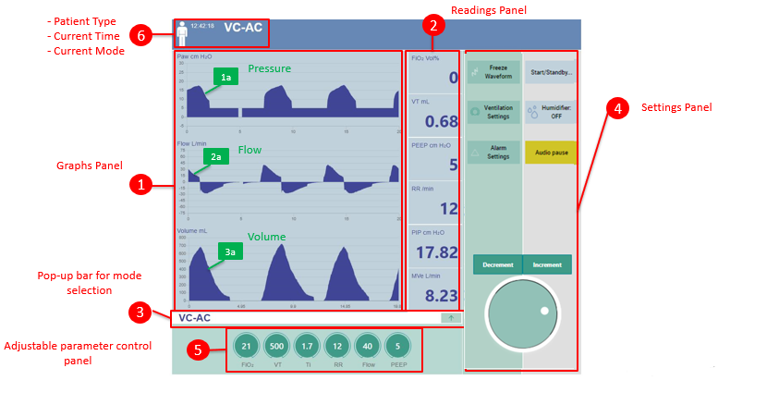

Figure 9: NuVENT Graphical User Interface

1). Selected Ventilation Mode Panel with Patient Particulars Panel

This panel is located at the top of the GUI screen. It shows the currently selected Ventilation mode. As we have studied previously in NuVENT we have collectively nine modes of ventilation. User selected mode appears on this top panel of GUI. Along with its icon/representation, patient type is provided. Icon of human indicates that patient under observation is adult.



Figure 10: Selected Ventilation Mode Panel

2). Adjustable Ventilation Parameters Control Panel

This panel is located at bottom of the GUI Screen. It is populated with set of adjustable parameters of ventilator. When the patient is linked with ventilator hardware system interfacing with the NuVENT Software Application. Modifying these parameters by physician or trained staff aid in regulating pressure, volume and flow settings that eventually manages the desired ventilator operations to support patient life.

A *Knob Control* which is actually a button is provided at the left of this panel that is pressed to confirm the change in values of Control panel parameters. For Example, click on any control panel parameter and then click and drag on the *white ball* like button inside the Knob and drag it in circular way. Clockwise moment show positive numerical value changes and Anti-Clockwise moment show decrement in values. Adjustable Input Parameters in the Control Panel are: *Fraction of inspired oxygen* (FiO2), *Tidal Volume* (Vt), *Inspiration Time* (Ti), *Respiratory Rate Control* (RR), *Flow Rate* (Flow), and *Positive End Expiratory Pressure* (PEEP). The top of this control panel selected Ventilation mode is displayed. In order to change this mode, Up arrow sign button is clicked that pop-ups ventilator settings dialog box.



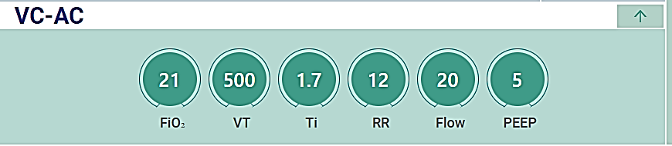

Figure 11: Adjustable Ventilation Parameters Control Panel

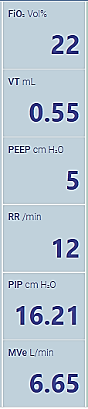

3). Monitored Ventilation Parameters Control Panel

This panel is located at the right of the GUI screen adjacent to the right panel and on its left side simulation graphs are displayed. This panels displays the numerical values of output parameters of ventilation operations that are result of complex mathematical calculations. Few of the Parameters are same as that of adjustable parameters found in *Adjustable Ventilation Parameters Control Panel* with a little variation. Each parameter reading is displayed along with Parameters name, recorded value, and units of measurement.

Figure 12: Monitored Ventilation Parameters Control Panel

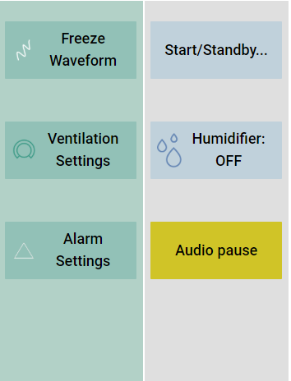4). General Settings Panel

Figure 13: General Settings Panel

This panel is located at the extreme right of the GUI screen. It contains controls/button that are used to handle basic settings of ventilator E.g. *Start/Stand By* button takes user to another screen that provide start/stand by in detail settings which is patient specific. *Humidifier On/Off* button is linked with hardware interface that enables humidity on and off. Audio Pause is linked to Alarm settings of the ventilator when the alarm noise is not required by user. This button is clicked to stop it. Toggling this button works between On and Off audio settings.

5). Ventilator Settings Panel

Figure 14: Ventilator Settings Panel

This panel exists adjacent to General Setting Panel. It contains three features Freeze Waveform, Ventilator Settings and Alarm Settings. Freeze Waveform halts the motion of real time graphs running on the center of GUI. Ventilator Settings button, when triggered, open another dialog where all possible ventilator settings are provided. Next Alarm settings control is provided that opens alarm settings dialog when triggered.

6). Waveform Area Panel

This panel is the actual area of interest of user it contains three graphs. On x-axis there is time series. And on Y-axis there is PAW (Airway Pressure) values are shown. The crust and troughs of graph are linked with monitored ventilator parameters. Along with Airway pressure graphs, Flow and Volume graphs are also being updated in real time.

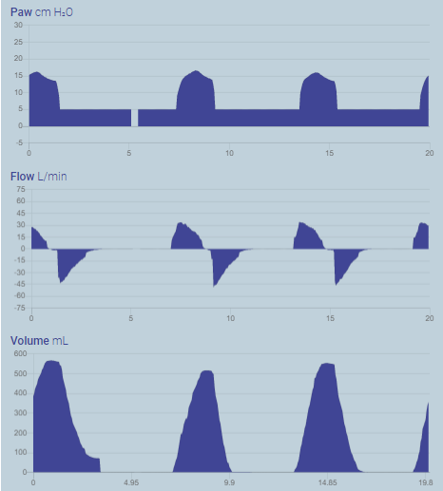

Figure 15:Waveform Area Panel

7). Ventilator Settings Dialog-VC-AC Mode

This Dialog Screen contains nine available ventilator modes out of which first seven modes of ventilator are mandatory for basic ventilator. Default selected ventilator mode is VC-AC . For this control following adjustable parameters are provided as presented in the below interface.

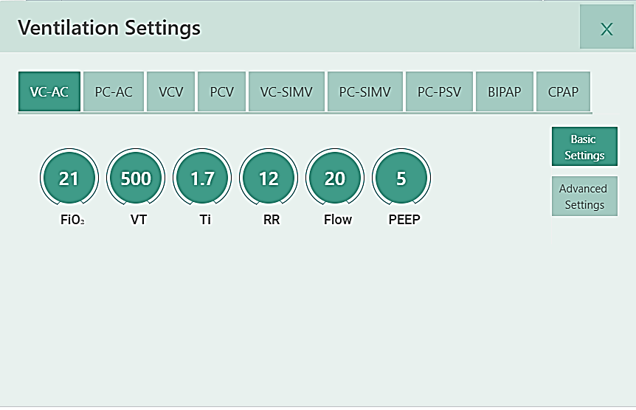

Figure 16:Ventilator Settings Dialog-VC-AC Mode

8). Ventilator Settings Dialog-PC-AC Mode

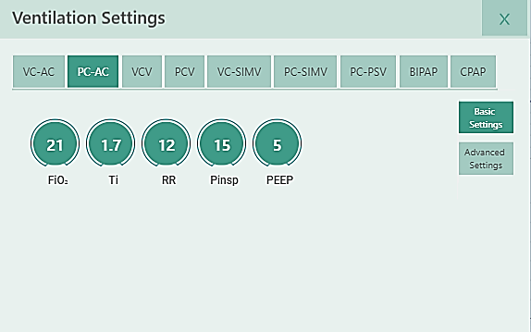

Figure 17:Ventilator Settings Dialog-PC-AC Mode

9). Ventilator Settings Dialog- VCV Mode

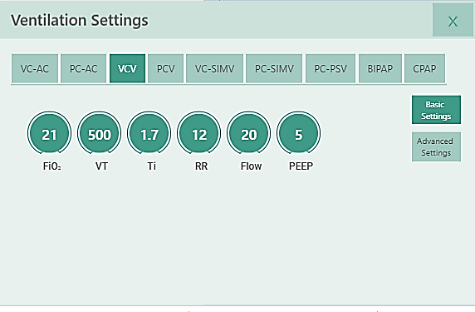

Figure 18:Ventilator Settings Dialog- VCV Mode

10). Ventilator Settings Dialog- PCV Mode

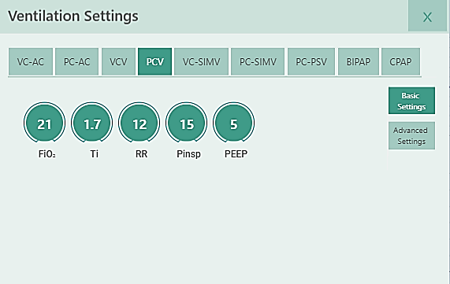

Figure 19:Ventilator Settings Dialog- PCV Mode

11). Ventilator Settings Dialog- VC-SIMV Mode

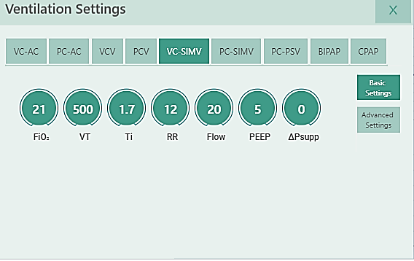

Figure 20:Ventilator Settings Dialog- VC-SIMV Mode

12). Ventilator Settings Dialog- PC-SIMV Mode

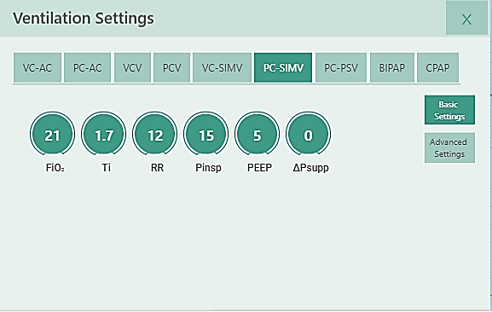

Figure 21:Ventilator Settings Dialog- PC-SIMV Mode

13). Ventilator Settings Dialog- PC-PSV Mode

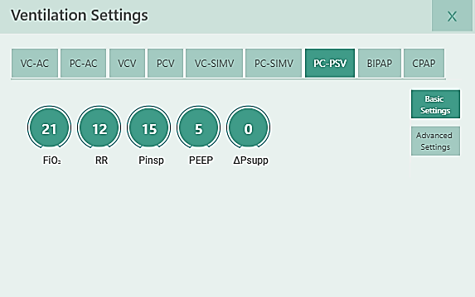

Figure 22:Ventilator Settings Dialog- PC-PSV Mode

14). Ventilator Settings Dialog- BIAP Mode

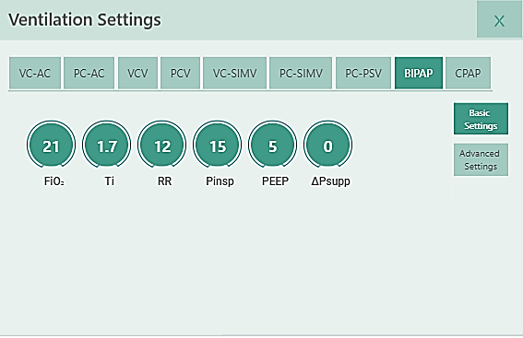

Figure 23:Ventilator Settings Dialog- BIPAP Mode

15). Ventilator Settings Dialog- CPAP Mode

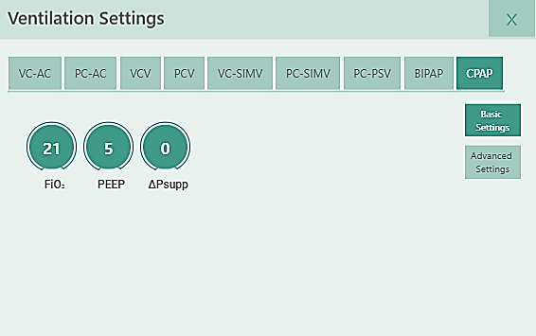

Figure 24: Ventilator Settings Dialog- CPAP Mode

16). Alarm Setting Dialog

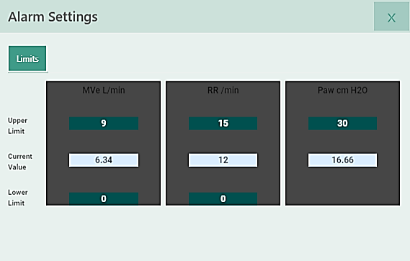

Figure 25: Alarm Setting Dialog

17). Start / Standby Dialog 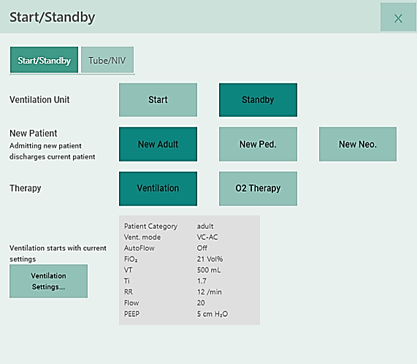

Figure 26: Start/Standby Dialog

18). Alarm Setting Dialog- Tube/NIV 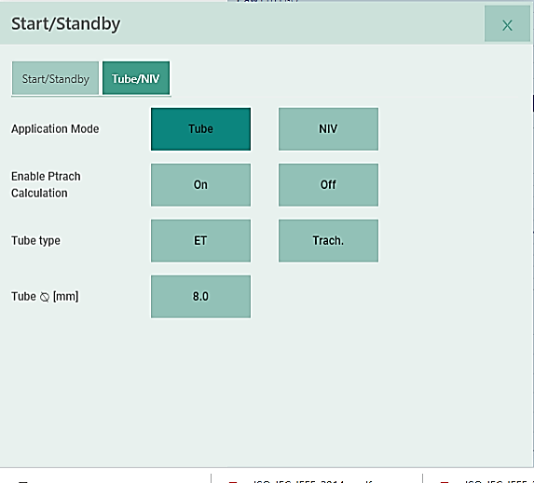

Figure 27:Alarm Setting Dialog- Tube/NIV

5.2. Communication Interfaces

5.2.1 Giga Bit Ethernet

Gigabit Ethernet is part of the Ethernet family of computer networking and communication standards. The Gigabit Ethernet standard supports a theoretical maximum data rate of one gigabit per second (1,000 Mbps). RJ45 connector for gigabit Ethernet. NuVENT application will be deployed on the web server that needs internet connection using Ethernet Port.

6. Standards compliance

|  |  |
| --- | --- |
| **Standard /Compliance** | **Description** |
| **FDA 21 CFR Part 820 and Part 11** | Guidance for the Content of  Premarket Submissions for Software  Contained in Medical Devices |
| AAMI SW68:2001; | Medical device software - Software life cycle processes |
| ISO 9000-3:1997, | Quality management and quality assurance standards—Part 3: Guidelines for the application of ISO 9001:1994 to the development, supply, installation, and maintenance of computer software. |